EUR/AUD: Big Picture Week 23/2/15 – 28/2/15
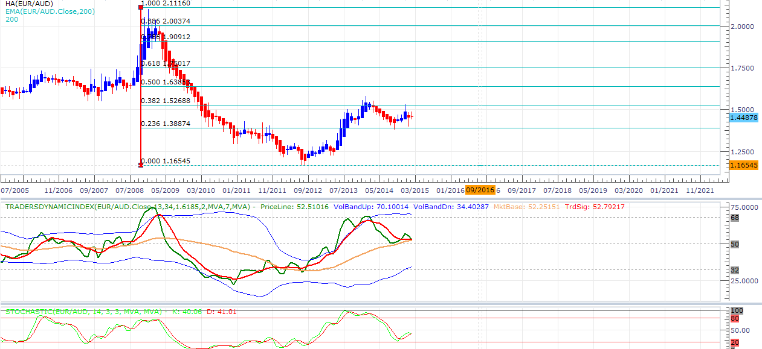
38.2% retracement of current downtrend shown on the monthly chart.
TDI, stoch both showing reversing signs.
Month open: 1.45129
PML: 1.39647
PMH: 1.48625
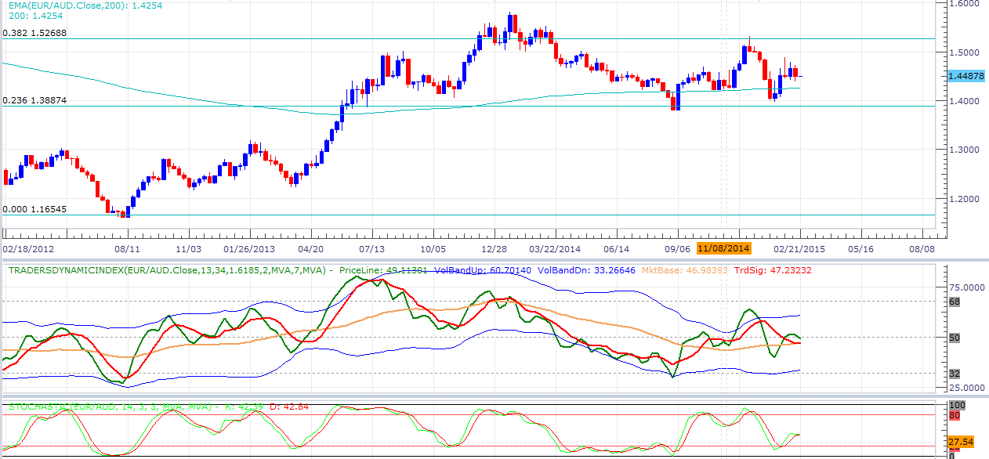
Weekly:
Previous week was bearish and tdi and stochs both showing checkmark reversal signs, 200 EMA at level 1.42553 could provide some support.
Key levels .236 fib 1.38874
.382 fib 1.52688
PWL: 1.43845
PWH: 1.47291
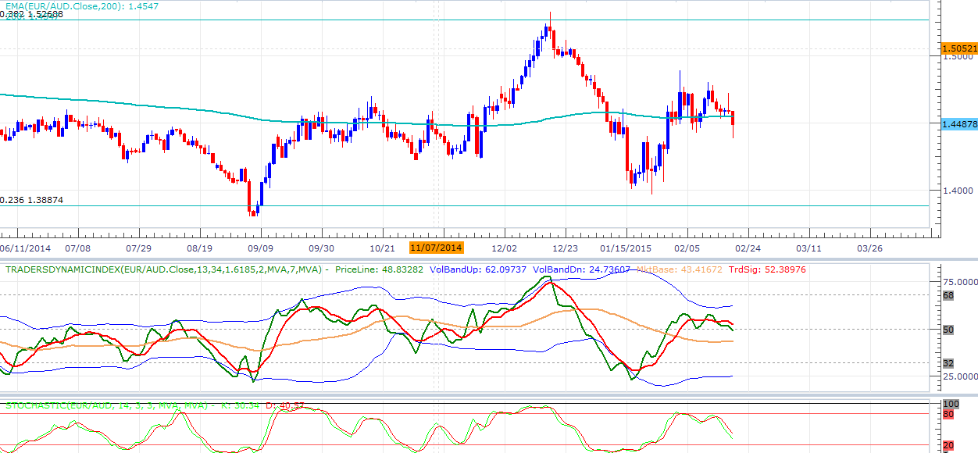
Close: 1.44878

Previous day very bearish, stochs heading down but not yet oversold, TDI has just crossed signaling a short entry, although may be too late.
Key levels:
PDL: 1.43845
PDH: 1.45930
Close: 1.44878

Conclusion:
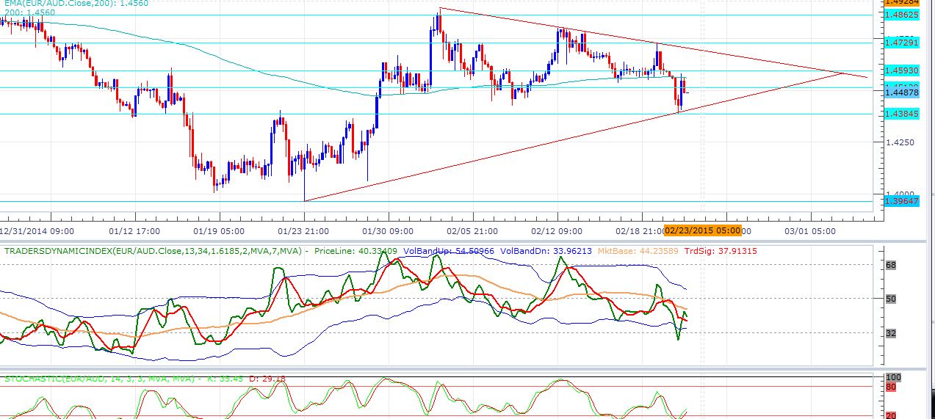
EA seems to be in a downtrend showing bearish signs on the monthly, weekly and daily chart.
On the 4h we have just broken the 200 EMA aswell as retested, stoch and TDI showing opposite signs so a entry may have to wait until the trending support or the PWL 1.43845 is broken.
If current bearish triangle pattern continues we could have to wait until a inevitable break on the 2/3.
Either way trade the breakouts, let p.a do the work for you and look for backup signals on the TDI.

ONLY SHORT.

